# FREEDOM INTERNATIONAL SCHOOL

### # 33, Sector IV, HSR Layout, Bengaluru, Karnataka 560102

SCHOOL CODE: 45175 AFFILIATION NUMBER:830183

**CHEMISTRY PROJECT ON**

**PIGMENTS AND POSTER PAINTS**

**SUBMITTED BY**

MANNITH NARAYAN

Class XI A

**Under the guidance of**

**Mr. ANIL**

**TGT/PGT- Chemistry**

**Vice Principal Principal**

**Ms. Clara David Ms. Sneha Rai**

**Freedom International School Freedom International School**

**Bangalore Bangalore**



**FREEDOM INTERNATIONAL SCHOOL**

# 33, Sector IV, HSR Layout, Bengaluru, Karnataka 560102

SCHOOL CODE: 45175 AFFILIATION NUMBER:830183

**CERTIFICATE**

This is to certify that the Chemistry Project Report entitled

**Pigments and Poster paints**

was carried out by MANNITH NARAYAN

of Class **XI A,**

### Roll No. 18 ,

a student of FREEDOM INTERNATIONAL SCHOOL

in partial fulfilment of the Chemistry Practical Examinations prescribed by the CBSE during the Academic Year 2019-2020.

I certify that this project has been done by him/her with his/her own effort under the guidance of the teacher.

#### Signature of the Teacher in Charge Signature of the Principal

**Mr. Anil Ms. Sneha Rai**

**Name of the Examiners Signature with date**

**1.**

**2.**

**ACKNOWLEDGEMENT**

I would like to express my special thanks and gratitude to my teacher and project guide Mr. Anil who gave me this wonderful opportunity to work on this interesting project, which required a lot of research and was an excellent learning experience.

My sincere thanks goes to Ms. Sneha Rai, our Principal, for her coordination in extending every possible support for the completion of this project.

I also extend my sincere thanks to our lab assistant, Ms. Aruna P for her assistance during the project work.

I also thank my parents for their constant motivation and support.

Last but not least, I would like to thank all those who had helped me directly or indirectly towards the completion of this project.

**INDEX**

|  |  |  |
| --- | --- | --- |
| **Sl. No.** | **CONTENT** | **PAGE NO.** |
| 1 | INTRODUCTION | 5 |
| 2 | EXPERIMENT | 8 |
| 3 | REFERENCES | 14 |

**INTRODUCTION**

A pigment is a material that changes the colour of reflected or transmitted light as the result of wavelength-selective absorption. This physical process differs from fluorescence, phosphorescence, and other forms of luminescence, in which a material emits light. Many materials selectively absorb certain wavelengths of light. Materials that humans have chosen and developed for use as pigments usually have special properties that make them ideal for colouring other materials. A pigment must have a high tinting strength relative to the materials it colours. It must be stable in solid form at ambient temperatures.

For industrial applications, as well as in the arts, permanence and stability are desirable properties. Pigments that are not permanent are called fugitive. Fugitive pigments fade over time, or with exposure to light, while some eventually blacken.

Pigments are used for colouring paint, ink, plastic, fabric, cosmetics, food and other materials. Most pigments used in manufacturing and the visual arts are dry colorants, usually ground into a fine powder. This powder is added to a binder (or vehicle), a relatively neutral or colourless material that suspends the pigment and gives the paint its adhesion. A distinction is usually made between a pigment, which is insoluble in its vehicle (resulting in a suspension), and a dye, which either is itself a liquid or is soluble in its vehicle (resulting in a solution).

A colorant can act as either a pigment or a dye depending on the vehicle involved. In some cases, a pigment can be manufactured from a dye by precipitating a soluble dye with a metallic salt. The resulting pigment is called a lake pigment. The term biological pigment is used for all coloured substances independent of their solubility. Pigments appear the colours they are because they selectively reflect and absorb certain wavelengths of visible light. White light is a roughly equal mixture of the entire spectrum of visible light with a wavelength in a range from about 375 or 400 nanometers to about 760 or 780 nm.

When this light encounters a pigment, parts of the spectrum are absorbed by the molecules or ions of the pigment. In organic pigments such as diazo or phthalocyanine compounds the light is absorbed by the conjugated systems of double bonds in the molecule. Some of the inorganic pigments such as vermilion (mercury sulphide) or Cadmium yellow (cadmium Sulphide) absorb light by transferring an electron from the negative ion (S2- ) to the positive ion (Hg2+ or Cd2+). Such compounds are designated as charge-transfer complexes, with broad absorption bands that subtract most of the colours of the incident white light. The other wavelengths or parts of the spectrum are reflected or scattered. The new reflected light spectrum creates the appearance of a colour. Pigments can only subtract wavelengths from the source light, never add new ones.

The appearance of pigments is intimately connected to the colour of the source light. Sunlight has a high colour temperature, and a fairly uniform spectrum, and is considered a standard for white light. Artificial light sources tend to have great peaks in some parts of their spectrum, and deep valleys in others. Viewed under these conditions, pigments will appear different colours. Colour spaces used to represent colours numerically must specify their light source. Lab colour measurements, unless otherwise noted, assume that the measurement was taken under a D65 light source, or "Daylight 6500 K", which is roughly the colour temperature of sunlight.

**PRINCIPLE:**

The principle behind the working of pigments is related with how different substances have the ability to selectively absorb and reflect different light rays corresponding to their different wavelengths in the visible spectrum. Pigments appear the colours they are because they selectively reflect and absorb certain wavelengths of visible light. White Light is a mixture of all light rays of wavelength 400 nm – 700 nm. When this light encounters a pigment, parts of the spectrum are absorbed by the different components of the pigment. Some other wavelengths or parts of the spectrum are reflected and scattered.

The new reflected light spectrum creates the appearance of a colour. When this reflected light comes in contact with a Human Eye, the Brain perceives the light as the colour corresponding to its Wavelength. Pigments, unlike fluorescent substances can only subtract wavelengths from the source light, and can never add new ones.

**EXPERIMENT**

**AIM:** To prepare pigments and poster paints using various chemicals and reagents.

**MATERIALS REQUIRED:**

1. Filter Paper

2. 250 Ml Beaker

3. Conical Flask

4. Funnels

5. Distilled Water

6. Electronic Weighing Scale

7. Spatula

8. China Dish

9. Potassium Chromate

10. Lead Nitrate

11. Iron(III)Chloride

12. Potassium Ferrocyanide

**PROCEDURE:**

**Preparation of Prussian Blue**

1. Make a solution of hydrated iron (III) chloride by dissolving 5 grams of the salt in 50 mL of water. Stir the solution briskly, using a spatula, until the salt particles are properly dissolved in the water.

2. Make a solution of potassium ferrocyanide by dissolving 10 grams of the salt in 75 mL of water. Stir the solution briskly, using a spatula, until the salt particles are properly dissolved in the water.

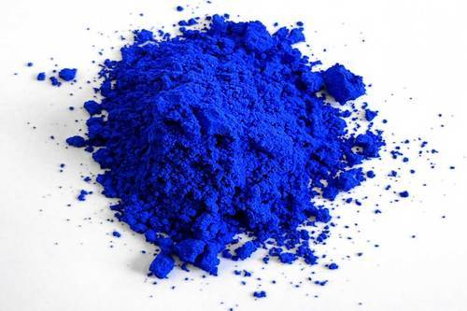

3. Add iron chloride solution, slowly, into potassium ferrocyanide solution while stirring briskly.

4. Leave the dark blue (Prussian blue) mixture,

so formed, undisturbed for 15 minutes.

5. Prepare a gravity filter by setting a folded filter paper in the form of a cone, which is stuck to the inner edge of a funnel, which is then set on a conical flask

6. Pour the mixture, slowly, over the gravity filter, and allow the powder to precipitate.

7. Once the filter paper is dried up, carefully remove the filter paper and pour the powder in a china dish.

8. Scrape the excess powder that is stuck on the filter paper, by using a spatula.

9. The powder obtained, is the paint pigment of the shade Prussian blue.

10.Weigh the powder formed on an electronic weighing scale, and calculate the efficiency of formation.

Reaction involved:

3K4[Fe(CN)6] +4FeCl3­ → Fe4[Fe(CN)6]3 + 12 KCl

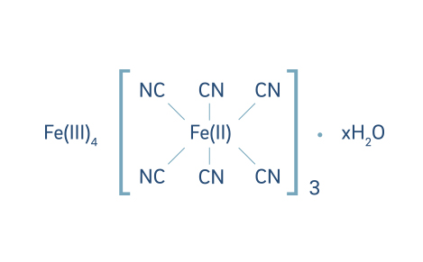

### 

### ***Iron(III)-hexacyanoferrate(II) x H2O***

**Preparation of Chrome Yellow**

1. Make a solution of potassium chromate by dissolving 7 grams of the salt in 50 mL of water. Stir the solution briskly, using a spatula, until the salt particles are properly dissolved in the water.

2. Make a solution of lead nitrate by dissolving 10 grams of the salt in 100 mL of water. Stir the solution briskly, using a spatula, until the salt particles are properly dissolved in the water.

3. Add potassium chromate solution, slowly, into lead nitrate solution while stirring briskly.

4. Leave the yellow (chrome yellow) mixture, so formed, undisturbed for 15 minutes.

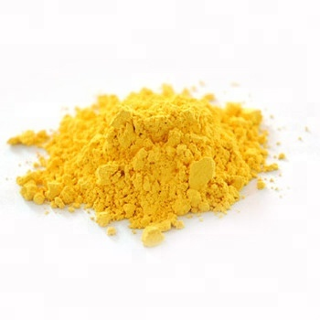 5. Prepare a gravity filter by setting a folded filter paper in the form of a cone, which is stuck to the inner edge of a funnel, which is then set on a conical flask

6. Pour the mixture, slowly, over the gravity filter, and allow the powder to precipitate.

7. Once the filter paper is dried up, carefully remove the filter paper and pour the powder in a china dish.

8. Scrape the excess powder that is stuck on the filter paper, by using a spatula.

9. The powder obtained, is the paint pigment of the shade chrome yellow.

10.Weigh the powder formed on an electronic weighing scale, and calculate the efficiency of formation.

Reaction involved:

K2CrO­4­­ + Pb(CH3COO)2 → PbCrO4 + 2 CH3COOK

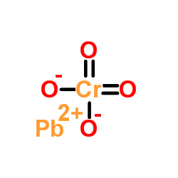

***Lead(II)Chromate***

**RESULT:**

**Prussian Blue**

Amount of Reactants = ____ g

Amount of Pigment formed = ____ g

Efficiency = ____ %

**Chrome Yellow**

Amount of Reactants = ____ g

Amount of Pigment formed = ____ g

Efficiency = ____ %

**PRECAUTIONS:**

1. All apparatuses used for the experiment should be properly cleaned before use so as to prevent any unnecessary addition of impurities.

2. All chemicals used should be accurately measured. If more or less than the required amount is used, then the pigment may not be formed efficiently.

3. Make sure the right chemicals are used else an unwanted reaction may take place, which may thus lead to incorrect results.

4. Filtration of the pigment should be done carefully so as to get maximum amount of pigment.

**REFERENCES**

1. Wikipedia
2. CompoundChem
3. Quora